Forward Engineering:

Github repo:

Why java was not suitable?
The previous system was written in Java Swing, which:
- Lacked responsiveness and modern UI capabilities
- Was tightly coupled (UI + logic mixed in the same files)
- Was not web-accessible
- Increased maintenance difficulty
- Had outdated architectures (file-based DB operations, no modularity)
- Required local installation on every machine
Because of these limitations, modernization was necessary.

Why React was chosen?
React was selected as the new UI framework because it directly improves functional + non-functional requirements:

Functional Requirements
Requirement | React Benefit
Dynamic POS UI | React’s component-based architecture updates UI instantly
Faster item search | Virtual DOM provides real-time rendering
User-friendly screens | Supports advanced UI libraries (MUI, Tailwind, AntD)
Multiple roles (Admin, Cashier) | Easy to create reusable layouts and routes

Non-Functional Improvements
NFR | How React Helps
Maintainability | Each page is an independent component
Scalability | Easy to add features (Return Item, Temp Item, Add Employee)
Reusability | Shared components (Buttons, Tables, Modals)
Performance | Virtual DOM improves speed
Cross-platform | Runs on any browser, no installation required

React’s component-driven architecture eliminates the tight coupling seen in Java Swing and increases system reuse, readability, testing ability, and maintainability.

Why Node.js + Express?
Node.js was chosen specifically because:

1. Same language across stack (JavaScript)
- Makes the project easier to maintain
- Reduces developer onboarding time
- Improves cross-team collaboration

2. Non-blocking, event-driven architecture
POS systems require:
- Fast reads
- High concurrency
- Real-time operations
Node.js excels at these workloads.

3. Express provides a clean API layer
Express makes it easier to build:
- Modular routes (/api/auth, /api/pos, /api/employees)
- Scalable controllers + services
- Middleware (auth, logging, validation)
This was impossible with the old Java Swing monolithic structure.

4. Better maintainability
Logic is separated into:
- Routes
- Controllers
- Services
- Database models
instead of mixed inside UI files (as in Java).

MongoDB:
- Schema flexibility for products, temp items, returns
- JSON storage → perfect match with Node.js
- Easy to scale
- High write throughput (POS systems write a lot)
- Simplifies nested data structures
- Quick to modify during rapid development

Refactored Modules and Data Structures:

Legacy Code:
- UI + logic mixed
- Non-reusable classes
- Shared mutable state
- No service layer
- No API boundaries

Refactored Code:

Frontend:
/src
/components
/pages
/services (api calls)
/models (ReturnItemModel, TempItemModel, UserModel)

Backend:
/routes
/controllers
/services
/models
/database

Mapping from legacy to new system:
Legacy Java Component | New React/Node Component
Login_Interface.java | Login.jsx + /api/auth/login
Register.java | Register.jsx
AddEmployee_Interface.java | AddEmployee.jsx + /api/employees
ReturnItem.java class | ReturnItemModel.js + /api/returns
newTemp.txt file | TempItems DB collection/table
PointOfSale.java | POS.jsx + /api/pos
File-based storage | Modern database

Architecture Diagram:
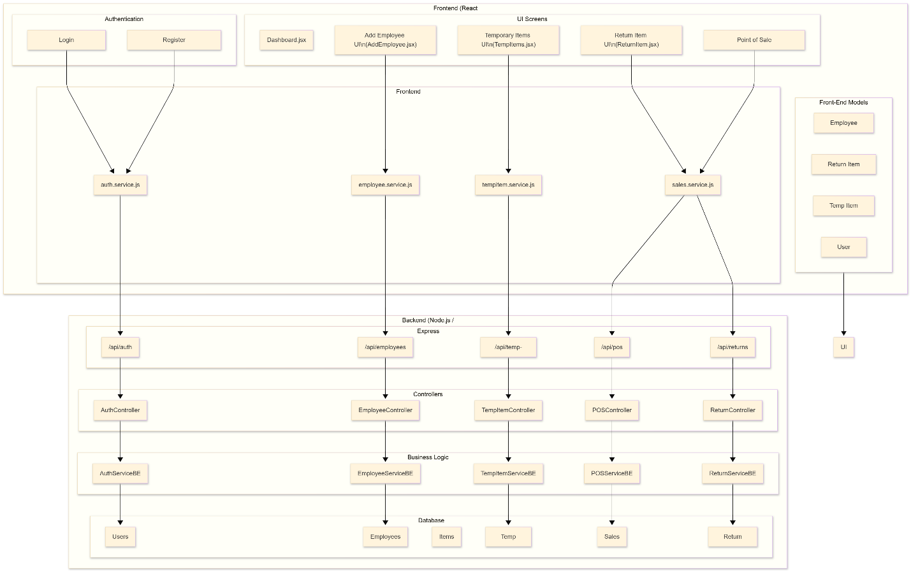

Class Diagram:
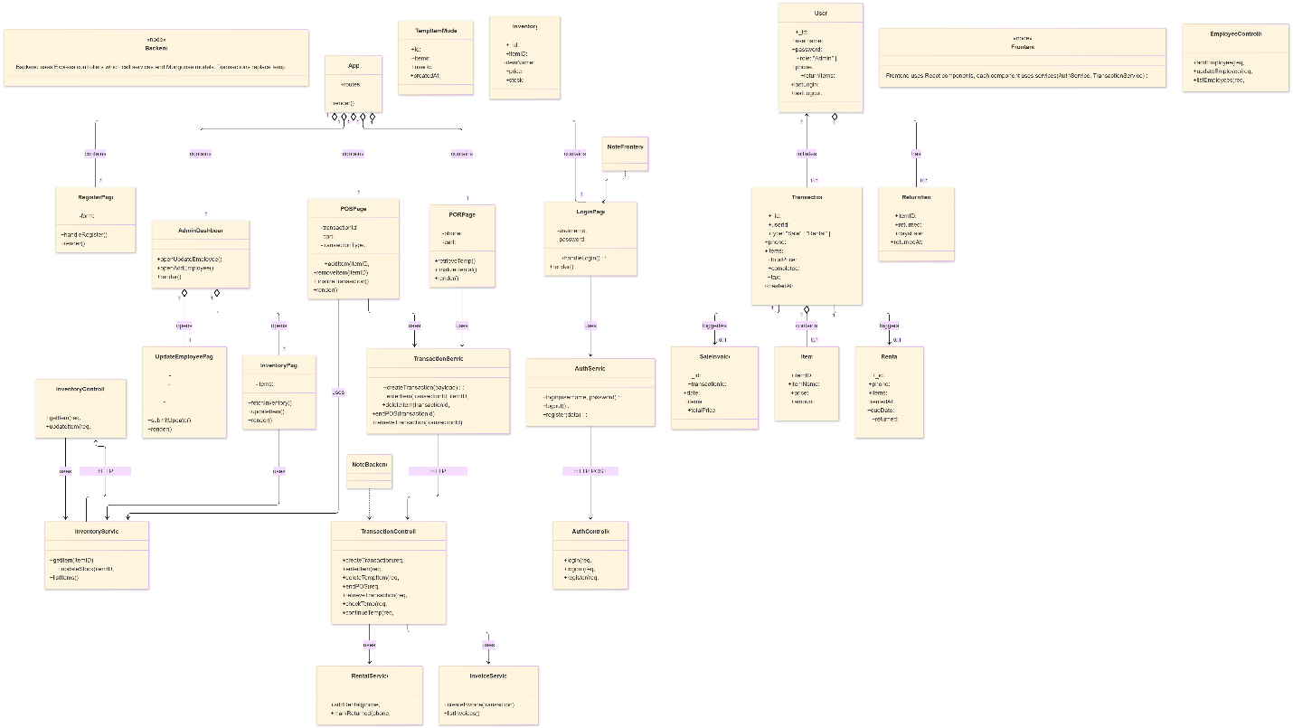

Entity-Relationship Diagram:
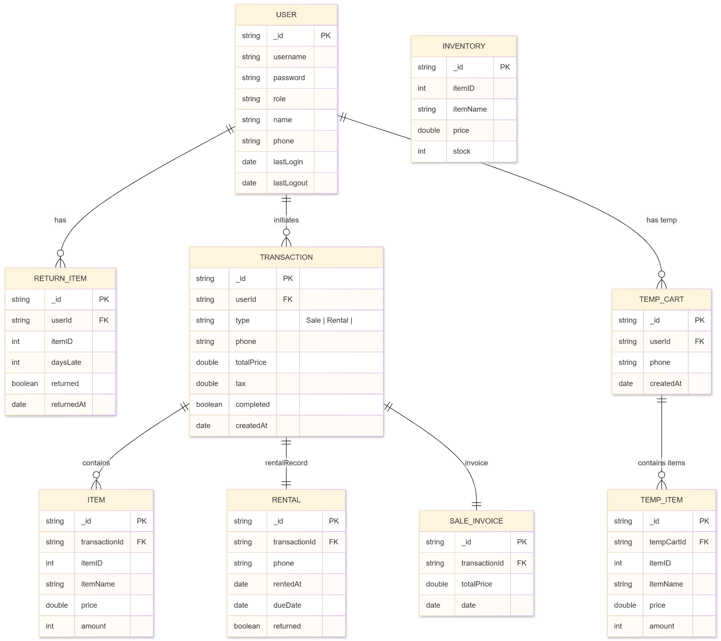

Risk Analysis:
Risk | Description | Likelihood | Impact | Mitigation Strategy
Data Loss During Migration | Migration from Java text-file storage to MongoDB may lead to missing or corrupted data. | High | Critical | - Create full backups before migration- Run test migrations in staging- Implement validation scripts to compare old vs new data- Keep legacy system read-only during migration
Inconsistent Data Model | The legacy app has no strict schema; data structures may not match new Mongoose models. | Medium | High | - Enforce strict Mongoose schemas- Apply constraints (required fields, min/max, enums)- Add validation middleware- Document schema decisions
API Failure / Server Downtime | Node.js server may crash or fail under load or due to unhandled errors. | Medium | High | - Implement error handling middleware- Use PM2 or Docker for process management- Add server health checks- Logging using Winston/Morgan
Client UI Failure | React components may break, causing incomplete or wrong transaction flow. | Medium | Medium | - Use React error boundaries- Implement unit tests for components- Validate inputs before API calls
Performance Bottlenecks | High-volume transactions could slow down database queries or UI updates. | Medium | Medium | - Use MongoDB indexing on frequently queried fields- Optimize React state management- Implement caching where appropriate
Inventory Mismatch | Race conditions during multiple sales or rentals could cause inaccurate stock levels. | Medium | High | - Use atomic MongoDB update operators ($inc)- Add server-side validation before transaction finalization- Log each stock adjustment
Integration Issues (React–Node–Mongo) | Data shape mismatch between frontend and backend can break workflows. | Medium | Medium | - Create a shared API schema contract- Use Postman Suite for endpoint testing- Use centralized error responses
User Training & Adoption Risk | Legacy users shifting from Java desktop UI to touch-friendly React UI may face usability issues. | Low | Medium | - Provide tooltips & onboarding UI- Keep UI simple and consistent- Add confirmation dialogs for critical actions
Hardware / Network Dependency | Web-based system relies on stable network unlike the offline Java program. | Low | High | - Provide offline fallback for critical flows (local caching)- Use retry logic in APIs- Host backend on reliable cloud service

